Bulletin
The Invercargill Parish of the Methodist Church of New Zealand.
Te Hahi Weteriana o Aotearoa.
Lindisfarne Methodist Church, Worship and Community Centre.
22 Lindisfarne Street. Invercargill 9812 Phone 216-0281.
e-mail: office@lindisfarne.org.nz Website: www.lindisfarne.org.nz
Lindisfarne Methodist Church.

Sunday January 23rd 2022.

10.00am: Lindisfarne Service led by Nicol Macfarlane.

1.00pm Tongan Service

Prayer:
We pray that the people of Tonga will get all the assistance and comfort necessary for them to cope with their disastrous experiences of the tsunami.

Calendar
Sunday 23rd  January | 10.00am  1.00pm | Lindisfarne Service with Nicol Macfarlane.  Tongan Service
Wednesday 26th | 9.00am  2.00pm  7.30pm | Oranga Tamariki.  Outreach Committee Meeting.  Choir Practice.
Friday 28th | 5.00pm | Setup for Saturday.
Saturday 29th | 10.00am | Private Booking.
Sunday 30th  January | 10.00am  1.00pm  1.00pm | Lindisfarne Service led by Neil Salter followed by church picnic. (See small green sheets in foyer.)  Tongan Service  Fijian Service

Church Secretary
We are sorry to lose Rosemary who has been our church secretary for twelve years. She has worked responsibly, often far beyond requirements and has become a friend to many of us.
Until a new secretary is appointed, Margaret will be in the office Monday to Friday from about 10.00 am until 1.00 pm.

A big Thank You! Grateful thanks to all those who helped to get the Waihopai Street house ready for Tania’s arrival. To the gardeners, the tree fellers, the repairers, the painters, those who sourced what was needed and those who donated to help with the cost, thank you. Too many to name but I must take the opportunity to give a special thank you to Neil and Daphne who were the absolute core of the internal upgrade.
Cam McCulloch

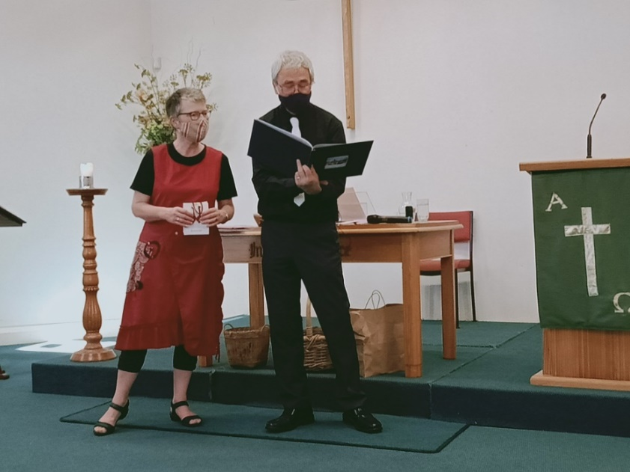

Noeline Collie took these pictures at Peter Taylor’s Farewell.

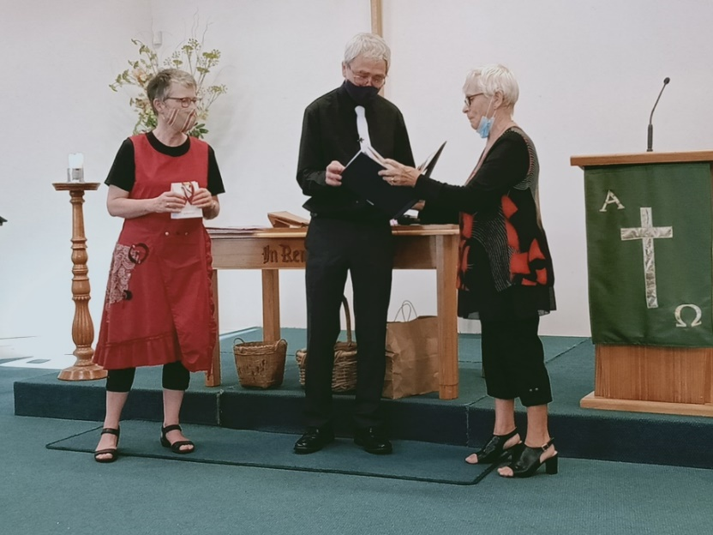

ROSTER FOR SUNDAY DUTIES.
Sunday | January 23rd | January 30th | February 6th | February 13th
DOOR | Nicol Macfarlane  Jessie Campbell | Daphne Salter  Christine Frame | Noeline Collie  Barbara Richardson | Evelyn Cruickshank
VAN |  | Ian Findlay | Bryon King | Daphne Salter
MORNING TEA | Carol and Keith McKenzie | Jo Templeton  Raewyn Birss | Nicol Macfarlane  Beverly Service | Betty Snell  Noeline Szabo
FLOWERS | Ita Safole | Raewyn Birss | Dorothy King | Mags Kelly
NOTICES | Barbara | Carolyn | Evelyn | Carolyn
CRECHE |  |  | Petra Weston | Carol McKenzie
KIDS KLUB | School Holidays | School Holidays | Waitangi Day | Fun Sunday

CENTRE DUTIES
WEEK OF | LAWNS | SECURITY
January 24th – January 30th | Findlay Collie | Runi Safole
January 31st – February 6th | Bryon King | Bryon King
February 7th – February 13th | Ian Findlay | Eddie Bremer
February 14th – February 20th | Nicol Macfarlane | Tony Weston

SOME INVERCARGILL PARISH KEY PERSONNEL
Minister Reverend Tania Shackleton
Parish Council Secretary Carolyn Weston
Parish Stewards Carolyn McDonald, Evelyn Cruickshank, Barbara Richardson
Parish Council- Chairman TBA |  |  | Treasurer David Little
Prayer Chain Co-ordinator |  | Mags Kelly
Bulletin Editors | Peter Lankshear Margaret Brass
Committee Conveners
Pastoral Care: Betty Snell Finance/Property: Cam McCulloch
Pastoral/Outreach: Noeline Collie Worship/Education: TBA
Health and Safety. Darren Weston

Congregational Representatives
Margaret Brass
Nicol Macfarlane Sarah Jenkin

